INTERIOR FUSEBOX (located under the glove box, its the panel with a hole in it and just pulls off)
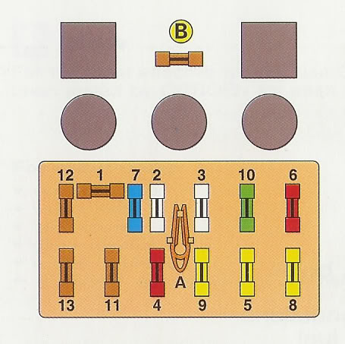
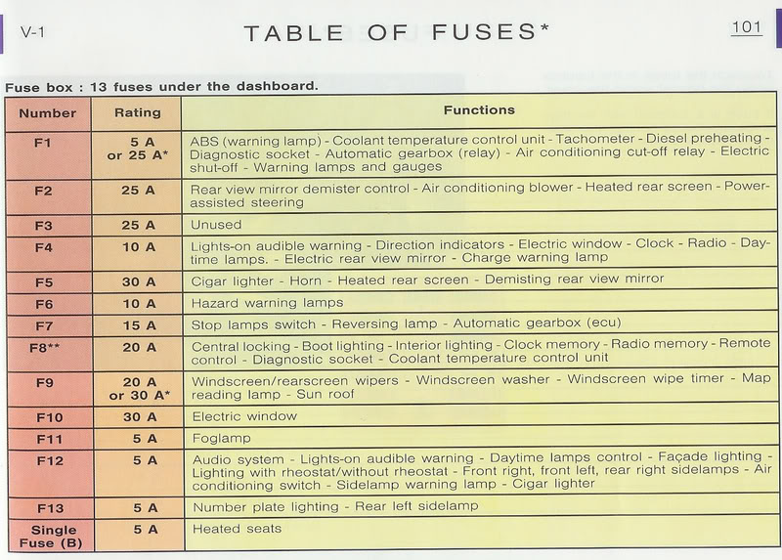
ENGINE FUSEBOX (located at the far right of the engine bay and simply unclips and lifts)
