Odyssey RB3 / MY13 (NAV) stereo wiring
The MY13 now comes with DVD/NAV/Bluetooth as standard, and it's a bit different from previous years' models.
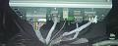
There's quite a bit going on in the back of here, so I'll post updates as I discover the mysteries within.
The main stereo loom (Connector "A"), whilst similar to previous models, is slightly different from anything I could find on the net:
Pin Colour Function
A1. Empty
A2. Empty
A3. Empty
A4. Green. Secuity System
A5. Purple. Steering Wheel Control Common
A6. Brown. Speaker (-) Right Rear
A7. Yellow. Speaker (+) Right Rear
A8. Empty
A9. Empty
A10. Pink. Speaker (-) Left Rear
A11. Blue. Speaker (+) Left Rear
A12. Brown. Ground
A13. Grey. Illumination
A14. Purple. Accessory
A15. Yellow. Vehicle Speed (1 Pulse = approx. 400m)
A16. Pink. Steering Wheel Control (stereo) input - see table below for resistances
A17. Empty
A18. Green. Speaker (-) Right Front (Mid and Tweeter in parallel)
A19. Red. Speaker (+) Right Front (Mid and Tweeter in parallel)
A20. Empty
A21. Empty
A22. Orange. Speaker (-) Left Front (Mid and Tweeter in parallel)
A23. White. Speaker (+) Left Front (Mid and Tweeter in parallel)
A24. Yellow. Backup Power
This drawing of the plug connector came from somewhere else on here, but the numbers are back-to-front from the Honda service manuals:
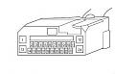
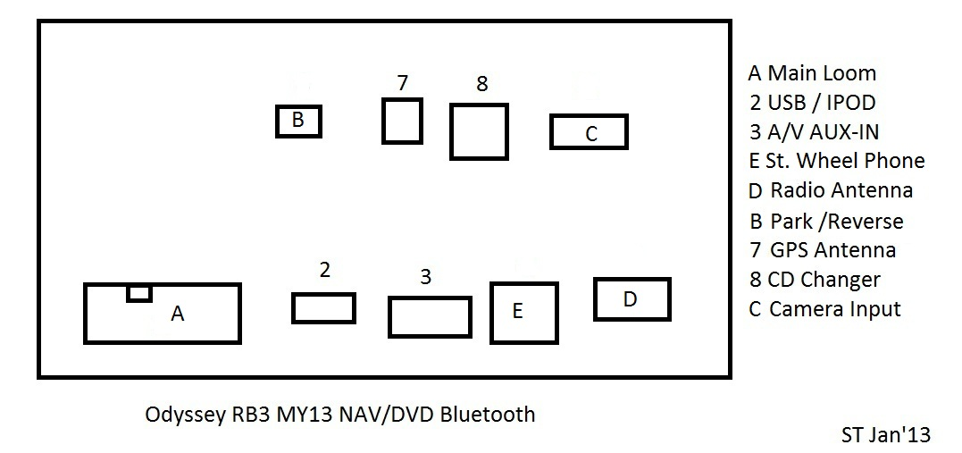

I found out the connector "B" is for the Parking Brake and Reverse Signals.
Pin Colour Function
B1. Empty
B2. Red. Reverse selected, +12V = reverse, GND = other
B3. Pink. Parking Brake, GND = Park brake on, open = off
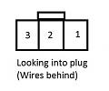

The Resistances for the stereo controls in the steering wheel are between A5 (Purple) and A16 (Pink):
All Off = 10k ohm
Vol down = 100 ohm
Vol Up = 370 ohm
CH (-) = 840 ohm
CH(+) = 2.04k ohm
MODE = 3.94k ohm
The connector E is for the telephone buttons, Purple is common, Green is Signal.
Don't get confused with the purple and green in the main A plug.
E1. Empty
E2. Purple. Steering Wheel Phone Button Common (Connected to Purple A5 in Loom)
E3. Green. Steering Wheel Phone Button Signal.
E4. to E12. Empty
The resistances for the phone buttons are:
All off = 10k Ohms
Hang Up = 47 Ohms
Pick Up = 227 Ohms

Next is the Camera Connector "C"
The original wiring is a bit different from the manual, so I'll go with the colours being correct.
C1. Green. Camera Power 5V
C2. Red. Camera Ground
C3. Empty
C4. White. Video Ground
C5. Black. Video Composite Signal
C6. Grey. Screen
C7. Yellow. "ADPT" - camera enable (still need to figure this one out.
The pin assignments for the Green AUX input connector are:
1. Option enable (short to pin 2)
2. Option common
3. Right Channel input
4. Audio Ground
5. Left Channel Input
This cable is available on ebay for a few bucks, or from Metra Online

better pictures of the factory unit (now removed)
The rear panel showing the connectors as described previously
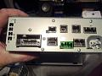
and the model number of the unit
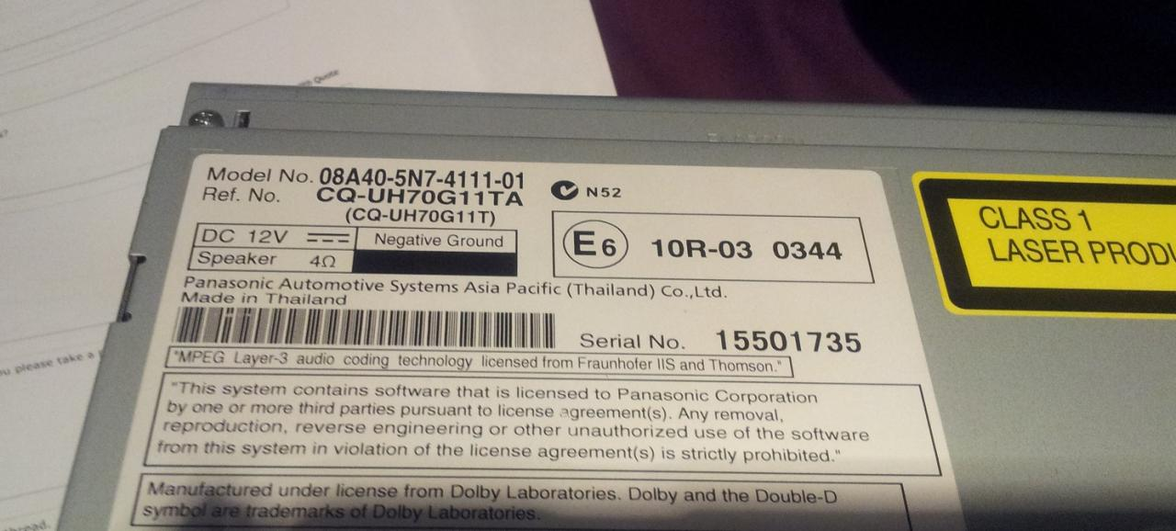

Wiring in an aftermarket steering wheel control adaptor for 2009+ Odyssey
These instructions are for wiring a PAC SWI-X into a 2009-2012 Honda Odyssey.
The SWI-X is designed for head units that do NOT have a rear socket input for the adaptor - i.e. head units that rely on an IR remote only.
Preparation and wiring in;
Disconnect the earth in the engine bay
Locate the wires you'll need on the factory harness/loom
- Pin 1 - black - earth/ground
Pin 23 - purple - Acc
Pin 21 - pink (thin)
Pin 8 - purple (thin)
Connect the red SWI-X Acc power wire to pin 23 (purple) on the car loom
Connect the black SWI-X ground wire to pin 1 (ground) on the car loom
Connect the white SWI-X signal sender wire to pin 8 (other purple) on the car loom
Connect a jumper wire between pin 21 (pink) and pin 1 (ground)
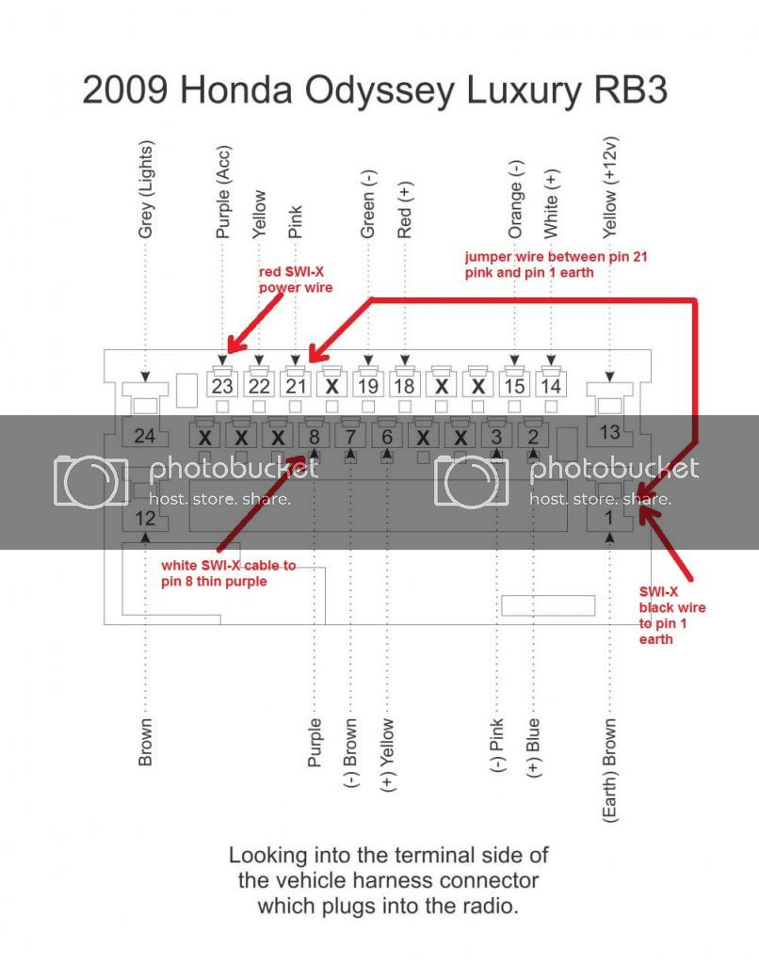
(Thanks to Mr Honda for the original plug diagram)
On the SWI-X, cut the purple loop wire and connect the 560 Ohm resistor (with green, blue, brown stripes) that came in the packet between the inner length of the purple loop wire and the white sender wire. Here's mine from tonight
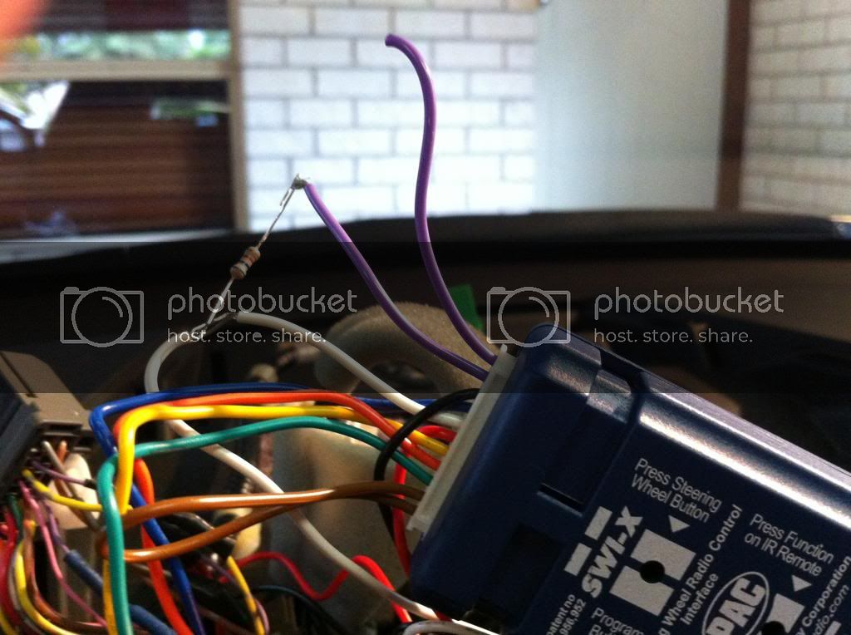
Reconnect the ground on the battery.
Programming;
1. Press and hold down the programming button on the SWI-X
2. Turn the key in the ignition to Acc
3. Let go of the program button on the SWI-X
4. Within 7 seconds, push the program button nine (9) times and then wait
5. After a few seconds, the SWI-X leds will flash back at you 9 times to confirm the version number - version 9.
6. Turn the Acc off with the car keys
7. Turn the Acc back on
8. Press and let go the program button on the SWI-X
9. Press the Mode button on the steering wheel and let go of it once the light on the SWI-X goes out
10. Within 7 seconds, aim the head unit remote control at the SWI-X sensor located next to the program button, pressing the corresponding Mode button on the IR remote at the same time
11. Let it go when the SWI-X light goes out
12. Press the volume up on the steering wheel
13. Within 7 seconds, aim and press the correspondng IR remote control button until the SWI-X light turns off
Repeat steps 9-13 until all the steering wheel buttons are programmed
14. When finished, let the SWI-X time out after 7 seconds and it will flash to confirm programming is saved and completed.
15. Position the SWI-X remote sender bulb (on the end of the long cable that comes out the opposite end of the multi-coloured SWI-X loom) within eyesight of the remote sensor on your head unit. Try to avoid direct sunlight or bright light on the sender and receiver otherwise the function will be impaired. If this cannot be avoided, try fashioning a small half round plastic cap peak out of a texter pen to shield each sender/receiver.
I did this tonight for my Clarion HX-D2 in my 2010 Ody Lux and it works perfectly. Here's my sender mounted neatly into my front ceiling light
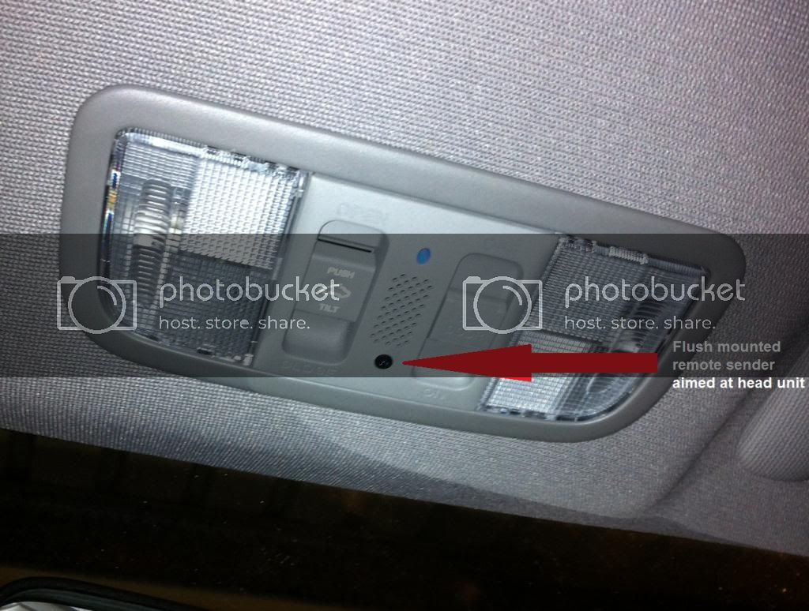

Honda Odyssey (RB3 – RB4) (2008 – 2013) – fuse box diagram
Year of production: 2008, 2009, 2010, 2011, 2012, 2013

Primary Under-Hood Fuse Box
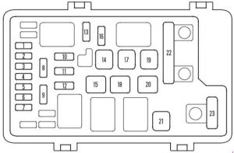Honda Odyssey – fuse box diagram – primary under-hood
No. | A | Circuit Protected
1 | 10 | Left Headlight Low
2 | 30 | Rear Defroster Coil
3 | 10 | Left Headlight High
4 | 15 | Small Lights
5 | 10 | Right Headlight High
6 | 10 | Right Headlight Low
7 | 7.5 | Back Up
8 | 15 | FI ECU (PCM)
9 | 30 | Condenser Fan
10 | – | Not used
11 | 30 | Cooling Fan
12 | 7.5 | MG Clutch
13 | 20 | Horn, Stop
14 | 30 | Rear Defroster
15 | 40 | Back Up, ACC
16 | 15 | Hazard
17 | 30 | VSA Motor
18 | 30 | VSA
19 | 30 | Option 1
20 | 40 | Option 2
21 | 40 | Heater Motor
22 | 70 | Passenger’s Fuse Box
22 | 120 | Battery
23 | 50 | IG1 Main
23 | 50 | Power Window Main
23 | 40 | Power Window Main

Secondary Under-Hood Fuse Box
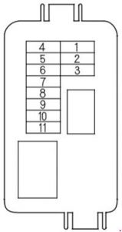Honda Odyssey – fuse box diagram – secondary under-hood
No. | A | Circuit Protected
1 | – | Not Used
2 | 40 | Left Power Sliding Door
3 | 40 | Right Power Sliding Door
4 | 40 | Power Tailgate
5 | 20 | Premium
6 | 20 | AC Inverter
7 | 20 | Fog Light
8 | 10 | ACM
9 | 20 | AS power Seat Slide
10 | 20 | AS power Seat Recline
11 | 7.5 | Rear Entertainment System

Driver Side Fuse Box
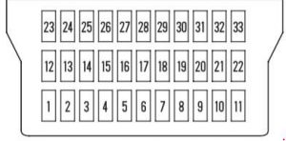Honda Odyssey – fuse box diagram – instrument panel – driver side
No. | A | Circuit Protected
1 | 7.5 | TPMS
2 | 15 | IG Coil
3 | 10 | Daytime Running Light
4 | 15 | LAF
5 | 10 | Radio
6 | 7.5 | Interior Lights
7 | 7.5 | Back Up
8 | – | Not Used
9 | 15 | Front Accessory Socket
10 | 7.5 | OPDS
11 | 30 | IG Wiper
12 | 15 | Rear Accessory Socket
13 | 20 | Left Power Sliding Door Closer
14 | 20 | Driver Power Seat Slide
15 | 20 | Pedal Position Adjustment
16 | 20 | Dr Power Seat Recline
17 | 20 | Power Tailgate Closer
18 | 15 | IGACG
19 | 15 | IG Fuel Pump
20 | 10 | IG Washer
21 | 7.5 | IG Meter
22 | 10 | IG SRS
23 | 7.5 | IGP
24 | 20 | Left Rear Power Window
25 | 20 | Right Rear Power Window
26 | 20 | Passenger’s Power Window
27 | 20 | Driver’s Power Window
28 | 20 | Moonroof
29 | – | Not Used
30 | 10 | IGHAC
31 | 15 | IG SOL
32 | 10 | ACC
33 | 7.5 | HAC OP
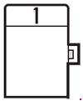Honda Odyssey – fuse box diagram – instrument panel – driver side
No. | A | Circuit Protected
1 | 7.5 | STS

Passenger Side Fuse Box
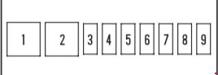Honda Odyssey – fuse box diagram – instrument panel – passenger side
No. | A | Circuit Protected
1 | 30 | Rear Blower
2 | – | Not Used
3 | 15 | DBW
4 | 20 | Door Lock
5 | – | Not Used
6 | 15 | Heated Seat
7 | 7.5 | Instrument Panel
8 | 20 | Right Power Sliding Door Closer
9 | – | Not Used
WARNING: Terminal and harness assignments for individual connectors will vary depending on vehicle equipment level, model, and market.

